Fermat's Spiral
# Source: AI Source: Provided by: [Data Path: Persons Table -> ID Column: 1, Name_En Column: Motasem Essam] -> From: [ChatGPT] on [7/25/2026]
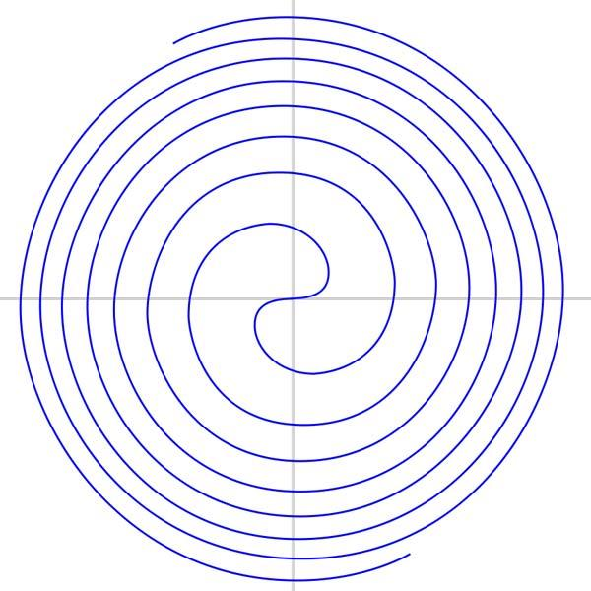
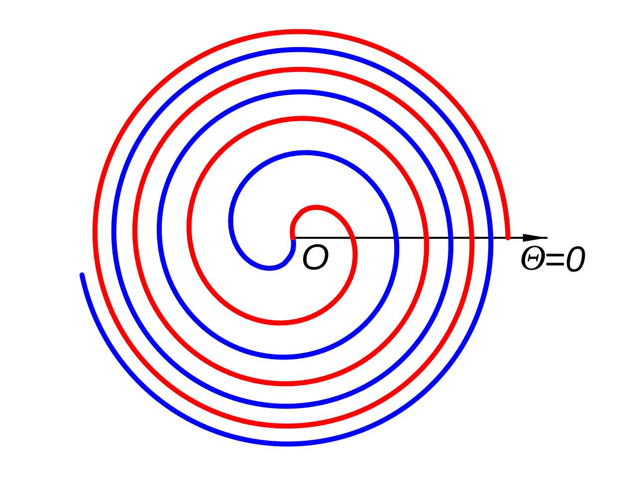
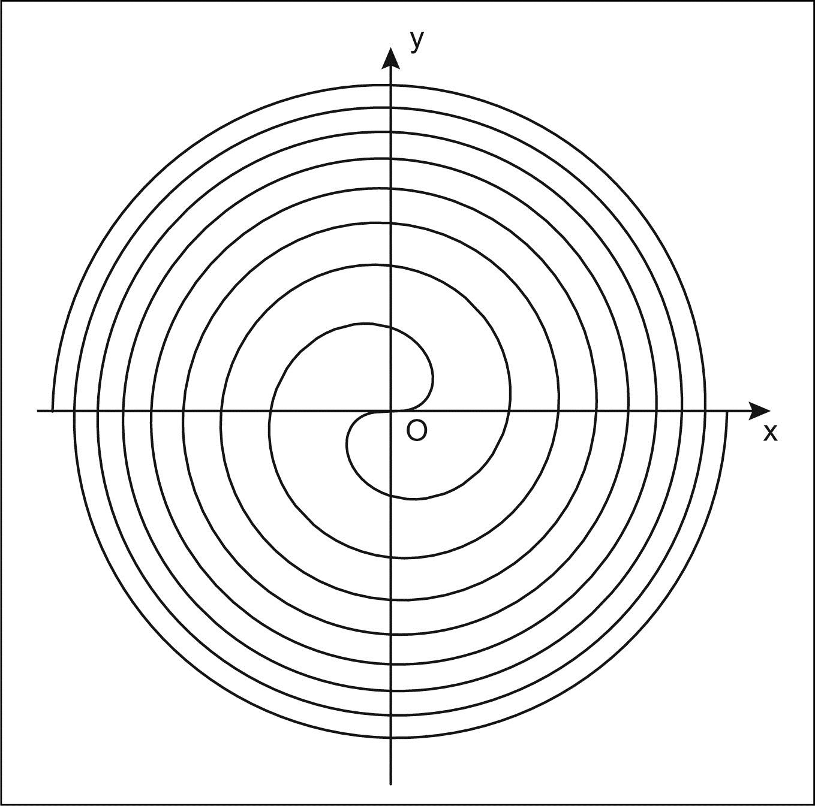
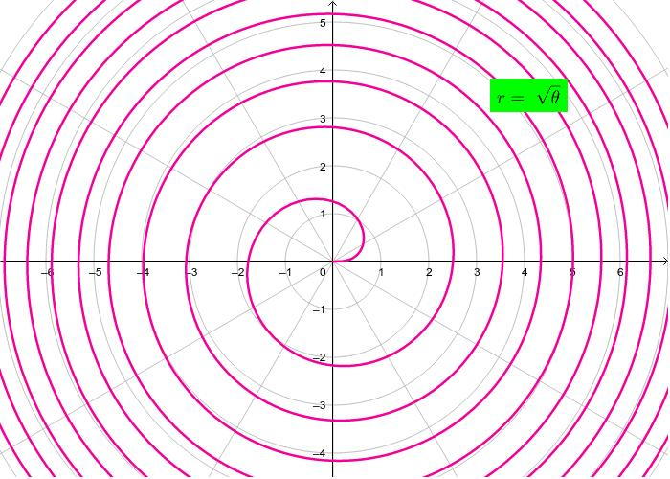
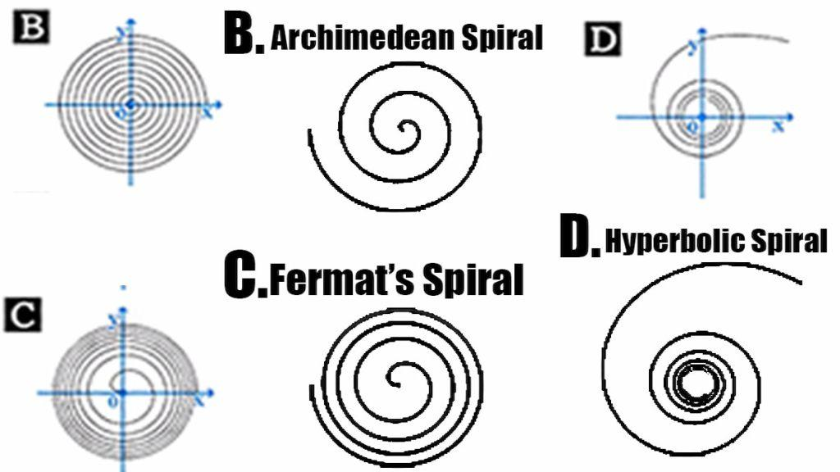
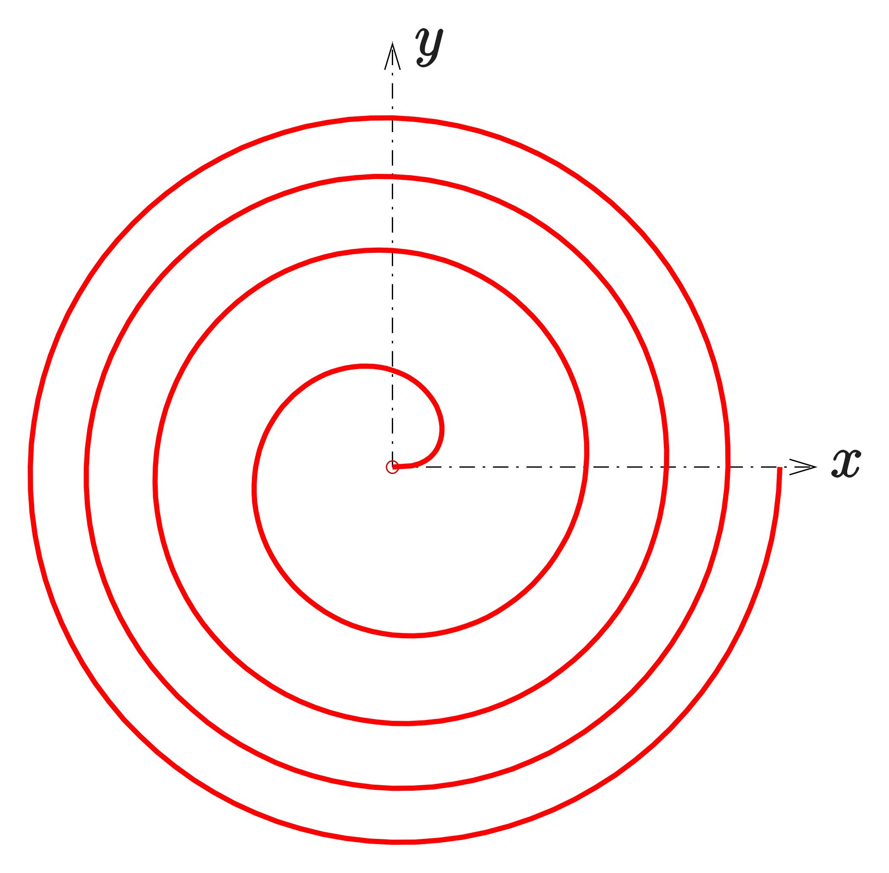

Definition
# Source: AI Source: Provided by: [Data Path: Persons Table -> ID Column: 1, Name_En Column: Motasem Essam] -> From: [ChatGPT] on [7/25/2026]
A Fermat's Spiral is a type of spiral whose radial distance from the pole is proportional to the square root of the angle.
Its standard polar equation is:
$$\boxed{r=a\sqrt{θ}}$$
where:
- $r$= radial distance from the pole
- $θ$= angular position
- $a$= constant controlling the scale of the spiral
- $θ≥0$in the standard form
The defining relationship can also be written as:
$$\boxed{r^{2}=a^{2}θ}$$

Fundamental Concept
# Source: AI Source: Provided by: [Data Path: Persons Table -> ID Column: 1, Name_En Column: Motasem Essam] -> From: [ChatGPT] on [7/25/2026]
Fermat's Spiral follows a square-root relationship between radius and angle:
$$r∝\sqrt{θ}$$
Therefore:
$$r^{2}∝θ$$
As the angle increases, the radius increases, but at a decreasing rate.
For example, if:
$$r=\sqrt{θ}$$
then:

$$θ$$ | $$r$$
$$0$$ | $$0$$
$$1$$ | $$1$$
$$4$$ | $$2$$
$$9$$ | $$3$$
$$16$$ | $$4$$
$$25$$ | $$5$$
Thus, multiplying the angle by $4$multiplies the radius by $2$.

Basic Structure
# Source: AI Source: Provided by: [Data Path: Persons Table -> ID Column: 1, Name_En Column: Motasem Essam] -> From: [ChatGPT] on [7/25/2026]
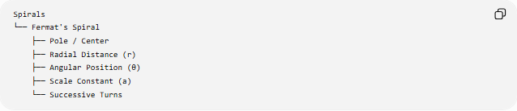
Spirals
└── Fermat's Spiral
├── Pole / Center
├── Radial Distance (r)
├── Angular Position (θ)
├── Scale Constant (a)
└── Successive Turns
The defining relationship is:
$$\boxed{r^{2}=a^{2}θ}$$

Standard Mathematical Representation
# Source: AI Source: Provided by: [Data Path: Persons Table -> ID Column: 1, Name_En Column: Motasem Essam] -> From: [ChatGPT] on [7/25/2026]
Polar Equation
$$\boxed{r=a\sqrt{θ}}$$
Squaring both sides:
$$\boxed{r^{2}=a^{2}θ}$$
Therefore:
$$\boxed{θ=\frac{r^{2}}{a^{2}}}$$

Parametric Form
Using:
$$x=r\cos{θ}$$
and
$$y=r\sin{θ}$$
we obtain:
$$\boxed{x=a\sqrt{θ}\cos{θ}} \\ \boxed{y=a\sqrt{θ}\sin{θ}}$$

Radial Growth
# Source: AI Source: Provided by: [Data Path: Persons Table -> ID Column: 1, Name_En Column: Motasem Essam] -> From: [ChatGPT] on [7/25/2026]
Differentiate:
$$r=a\sqrt{θ}$$
with respect to $θ$:
$$\boxed{\frac{dr}{dθ}=\frac{a}{2\sqrt{θ}}}$$
for $θ>0$.
Therefore:
$$\frac{dr}{dθ}>0$$
when $a>0$.
So the spiral moves outward as $θ$increases.
However:
$$\frac{dr}{dθ}→0$$
as:
$$θ→∞$$
Thus the radial growth becomes progressively slower.

Radius After One Complete Revolution
# Source: AI Source: Provided by: [Data Path: Persons Table -> ID Column: 1, Name_En Column: Motasem Essam] -> From: [ChatGPT] on [7/25/2026]
One complete revolution corresponds to:
$$Δθ=2π$$
At angle $θ$:
$$r_{1}=a\sqrt{θ}$$
After one revolution:
$$r_{2}=a\sqrt{θ+2π}$$
Therefore:
$$\boxed{\frac{r_{2}}{r_{1}}=\sqrt{\frac{θ+2π}{θ}}}$$
The radial difference is:
$$\boxed{Δr=a\left(\sqrt{θ+2π}-\sqrt{θ}\right)}$$
This difference decreases as $θ$becomes larger.

Number of Turns
# Source: AI Source: Provided by: [Data Path: Persons Table -> ID Column: 1, Name_En Column: Motasem Essam] -> From: [ChatGPT] on [7/25/2026]
The number of complete turns over an angular interval is:
$$\boxed{N=\frac{Δθ}{2π}}$$
For example, from:
$$θ=0$$
to:
$$θ=4π$$
the spiral makes:
$$N=\frac{4π}{2π}=2$$
complete turns.

Area Swept by the Spiral
# Source: AI Source: Provided by: [Data Path: Persons Table -> ID Column: 1, Name_En Column: Motasem Essam] -> From: [ChatGPT] on [7/25/2026]
For a polar curve:
$$A=\frac{1}{2}\int_{θ_{1}}^{θ_{2}}{r^{2}} dθ$$
Since:
$$r^{2}=a^{2}θ$$
we obtain:
$$A=\frac{1}{2}\int_{θ_{1}}^{θ_{2}}{a^{2}}θ dθ$$
Therefore:
$$\boxed{A=\frac{a^{2}}{4}\left(θ_{2}^{2}-θ_{1}^{2}\right)}$$
For the region swept from the pole to angle $θ$:
$$\boxed{A=\frac{a^{2}θ^{2}}{4}}$$

Area in Terms of Radius
# Source: AI Source: Provided by: [Data Path: Persons Table -> ID Column: 1, Name_En Column: Motasem Essam] -> From: [ChatGPT] on [7/25/2026]
Because:
$$r^{2}=a^{2}θ$$
we have:
$$θ=\frac{r^{2}}{a^{2}}$$
Substituting into the area expression:
$$A=\frac{a^{2}}{4}\left(\frac{r^{4}}{a^{4}}\right)$$
so:
$$\boxed{A=\frac{r^{4}}{4a^{2}}}$$
for the region swept from the pole to the corresponding angle.

Arc Length
# Source: AI Source: Provided by: [Data Path: Persons Table -> ID Column: 1, Name_En Column: Motasem Essam] -> From: [ChatGPT] on [7/25/2026]
For a polar curve:
$$L=\int_{θ_{1}}^{θ_{2}}{\sqrt{r^{2}+{\left(\frac{dr}{dθ}\right)}^{2}}} dθ$$
For Fermat's Spiral:
$$r=a\sqrt{θ}$$
and:
$$\frac{dr}{dθ}=\frac{a}{2\sqrt{θ}}$$
Therefore:
$$L=\int_{θ_{1}}^{θ_{2}}{\sqrt{a^{2}θ+\frac{a^{2}}{4θ}}} dθ$$
or:
$$\boxed{L=∣a∣\int_{θ_{1}}^{θ_{2}}{\sqrt{θ+\frac{1}{4θ}}} dθ}$$
The arc length generally requires a more advanced evaluation than the basic area formula.

Important Properties
# Source: AI Source: Provided by: [Data Path: Persons Table -> ID Column: 1, Name_En Column: Motasem Essam] -> From: [ChatGPT] on [7/25/2026]
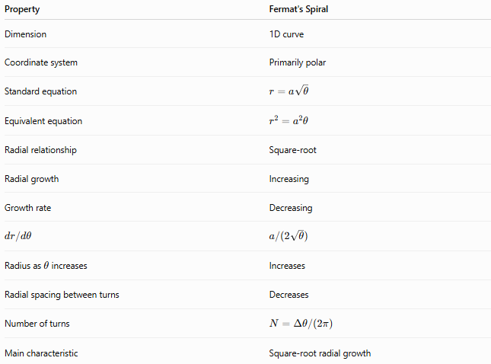
Property | Fermat's Spiral
Dimension | 1D curve
Coordinate system | Primarily polar
Standard equation | $$r=a\sqrt{θ}$$
Equivalent equation | $$r^{2}=a^{2}θ$$
Radial relationship | Square-root
Radial growth | Increasing
Growth rate | Decreasing
$$dr/dθ$$ | $$a/\left(2\sqrt{θ}\right)$$
Radius as $θ$increases | Increases
Radial spacing between turns | Decreases
Number of turns | $$N=Δθ/\left(2π\right)$$
Main characteristic | Square-root radial growth

Fermat's Spiral vs Other Spirals
# Source: AI Source: Provided by: [Data Path: Persons Table -> ID Column: 1, Name_En Column: Motasem Essam] -> From: [ChatGPT] on [7/25/2026]
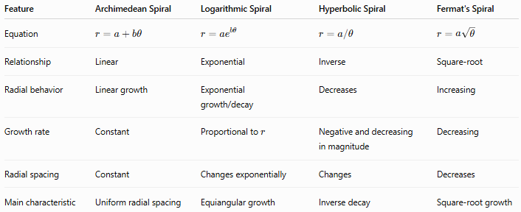
Feature | Archimedean Spiral | Logarithmic Spiral | Hyperbolic Spiral | Fermat's Spiral
Equation | $$r=a+bθ$$ | $$r=ae^{bθ}$$ | $$r=a/θ$$ | $$r=a\sqrt{θ}$$
Relationship | Linear | Exponential | Inverse | Square-root
Radial behavior | Linear growth | Exponential growth/decay | Decreases | Increasing
Growth rate | Constant | Proportional to $r$ | Negative and decreasing in magnitude | Decreasing
Radial spacing | Constant | Changes exponentially | Changes | Decreases
Main characteristic | Uniform radial spacing | Equiangular growth | Inverse decay | Square-root growth

Example
# Source: AI Source: Provided by: [Data Path: Persons Table -> ID Column: 1, Name_En Column: Motasem Essam] -> From: [ChatGPT] on [7/25/2026]
Consider:
$$\boxed{r=2\sqrt{θ}}$$
At:
$$θ=1 \\ r=2$$
At:
$$θ=4 \\ r=4$$
At:
$$θ=9 \\ r=6$$
At:
$$θ=16 \\ r=8$$
So:
$$θ↑ ⟹ r↑$$
but the rate of increase becomes smaller.

Two-Branch Form
# Source: AI Source: Provided by: [Data Path: Persons Table -> ID Column: 1, Name_En Column: Motasem Essam] -> From: [ChatGPT] on [7/25/2026]
A more general representation is sometimes written as:
$$\boxed{r=±a\sqrt{θ}}$$
The positive and negative signs can represent two branches of the curve under suitable angular conventions.
This form is particularly useful when discussing the complete symmetric form of Fermat's Spiral.
A common representation is:
$$\boxed{r^{2}=a^{2}θ}$$
which emphasizes its defining square relationship.

Symmetry
# Source: AI Source: Provided by: [Data Path: Persons Table -> ID Column: 1, Name_En Column: Motasem Essam] -> From: [ChatGPT] on [7/25/2026]
The complete Fermat's Spiral can be represented in forms that produce two opposite spiral arms.
A two-branch representation may be written as:
$$r=±a\sqrt{θ}$$
The branches are related through the polar-coordinate relationship between positive and negative radial values.
When represented as a two-armed Fermat spiral, the arms exhibit 180° rotational symmetry about the pole.
This is an important distinction from simply considering one branch of the standard $r=a\sqrt{θ}$representation.

Important Distinction
# Source: AI Source: Provided by: [Data Path: Persons Table -> ID Column: 1, Name_En Column: Motasem Essam] -> From: [ChatGPT] on [7/25/2026]
Fermat's Spiral should not be confused with the Archimedean Spiral.
Archimedean Spiral
$$\boxed{r=a+bθ}$$
The radius changes linearly with the angle.
Fermat's Spiral
$$\boxed{r=a\sqrt{θ}}$$
The radius changes according to the square root of the angle.
Therefore, the radial spacing between turns behaves differently:
$$\boxed{\text{Archimedean: constant spacing}} \\ \boxed{\text{Fermat: decreasing spacing}}$$

Classification
# Source: AI Source: Provided by: [Data Path: Persons Table -> ID Column: 1, Name_En Column: Motasem Essam] -> From: [ChatGPT] on [7/25/2026]
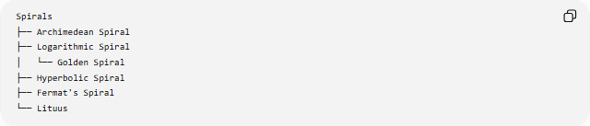
Spirals
├── Archimedean Spiral
├── Logarithmic Spiral
│ └── Golden Spiral
├── Hyperbolic Spiral
├── Fermat's Spiral
└── Lituus
Directional description
For:
$$r=a\sqrt{θ}, a>0$$
the radius increases as $θ$increases, so it is naturally described as an outward-growing spiral.
“Outward Fermat's Spiral” is a descriptive term rather than a separate fundamental mathematical family.

Key Points
# Source: AI Source: Provided by: [Data Path: Persons Table -> ID Column: 1, Name_En Column: Motasem Essam] -> From: [ChatGPT] on [7/25/2026]
- Fermat's Spiral is defined by a square-root relationship between radius and angle.
- Its standard equation is:
$$\boxed{r=a\sqrt{θ}}$$
- Equivalently:
$$\boxed{r^{2}=a^{2}θ}$$
- The radius increases as the angle increases.
- Its radial growth rate decreases:
$$\boxed{\frac{dr}{dθ}=\frac{a}{2\sqrt{θ}}}$$
- The spacing between successive turns decreases.
- The area swept from the pole to angle $θ$is:
$$\boxed{A=\frac{a^{2}θ^{2}}{4}}$$
- A two-branch representation can exhibit 180° rotational symmetry.
- It differs from the Archimedean Spiral because its radial growth is proportional to $\sqrt{θ}$, not $θ$.

Conclusion
# Source: AI Source: Provided by: [Data Path: Persons Table -> ID Column: 1, Name_En Column: Motasem Essam] -> From: [ChatGPT] on [7/25/2026]
A Fermat's Spiral is a spiral defined by the square-root relationship
$$\boxed{r=a\sqrt{θ}}$$
or equivalently:
$$\boxed{r^{2}=a^{2}θ}$$
As the angle increases, the spiral moves outward, but its radial growth becomes progressively slower. Consequently, the spacing between successive turns decreases. This square-root growth distinguishes Fermat's Spiral from the linear growth of the Archimedean Spiral, the exponential behavior of the Logarithmic Spiral, and the inverse behavior of the Hyperbolic Spiral.

